**\*Contributors to the plans for this document:**

- Trieu Huu Phuong

**\*Technologies, Tools, Pages, Features, Data, or anything that I will contribute:**

**+Main page first poster container**

**1.Main page first poster container**

**This container should be placed beneath the Top Navigation Bar**

I may make the first poster container content from website realtor.com

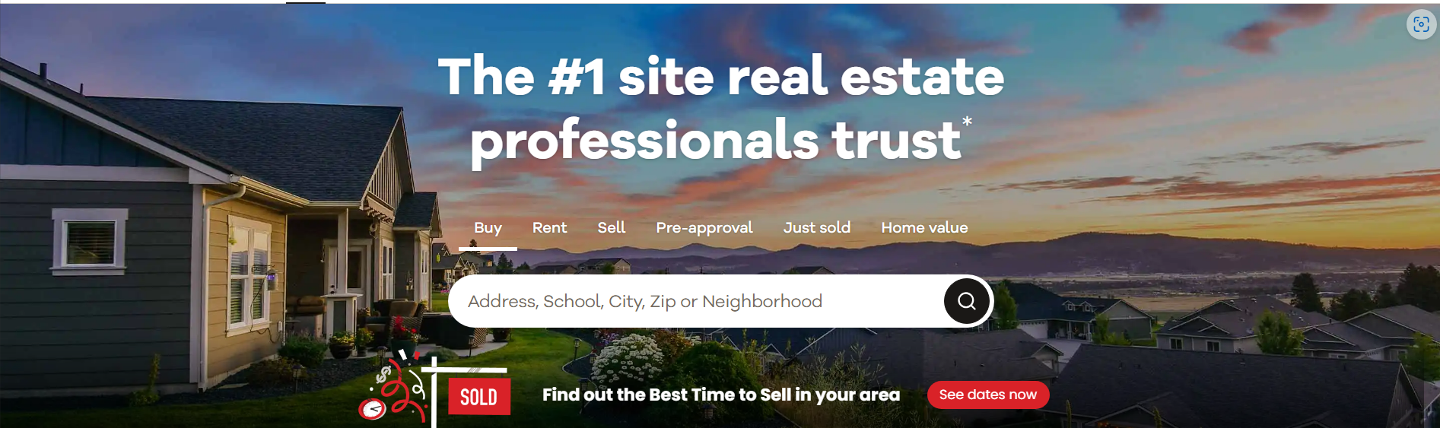

**I’ll use this poster image that I just designed on 04/03/2025**

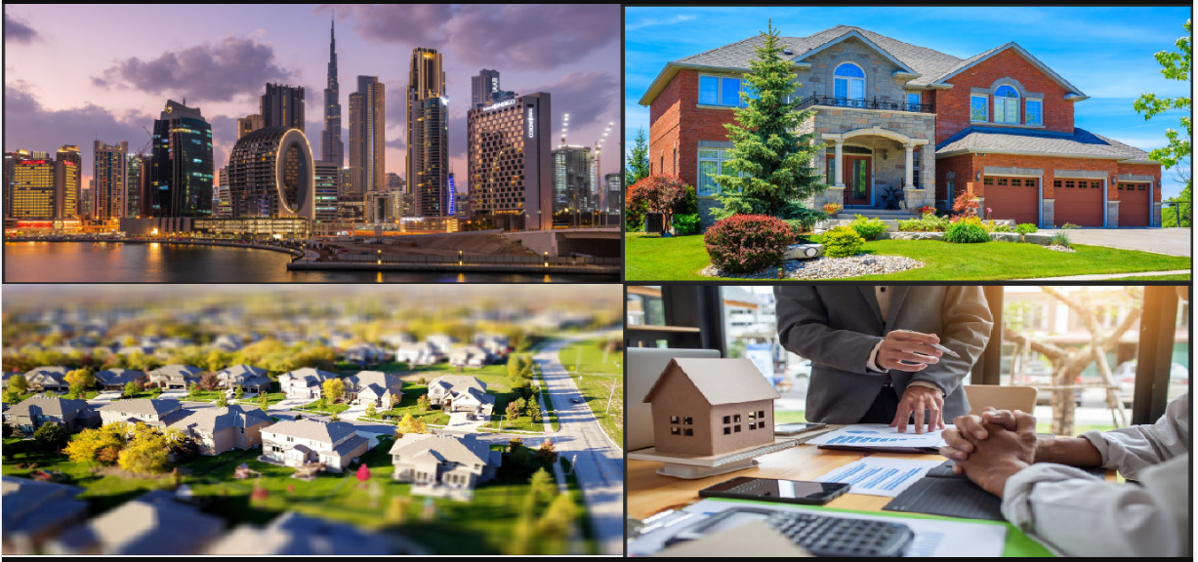

The content that appears in front of the poster must be a box with grayscale effect to make the poster darker a little bit

In front of the grayscale effect box, must be a chatbot to help users input any prompt to help the AI tools help them find their dream house(s).

Above the chatbot is the title: **The #1 AI site real estate professionals trust (font-family: Verdana, font-weight: bold)**



I may use the chatbox design idea from the resources below:

**MS Designer website**

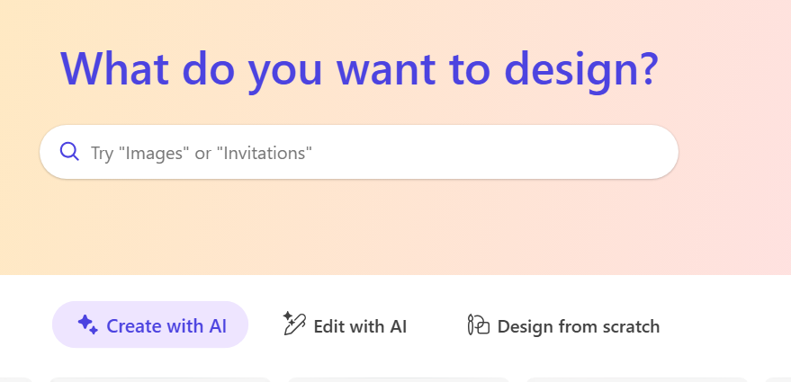

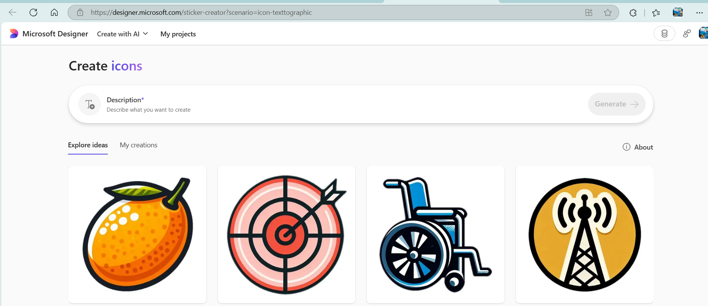

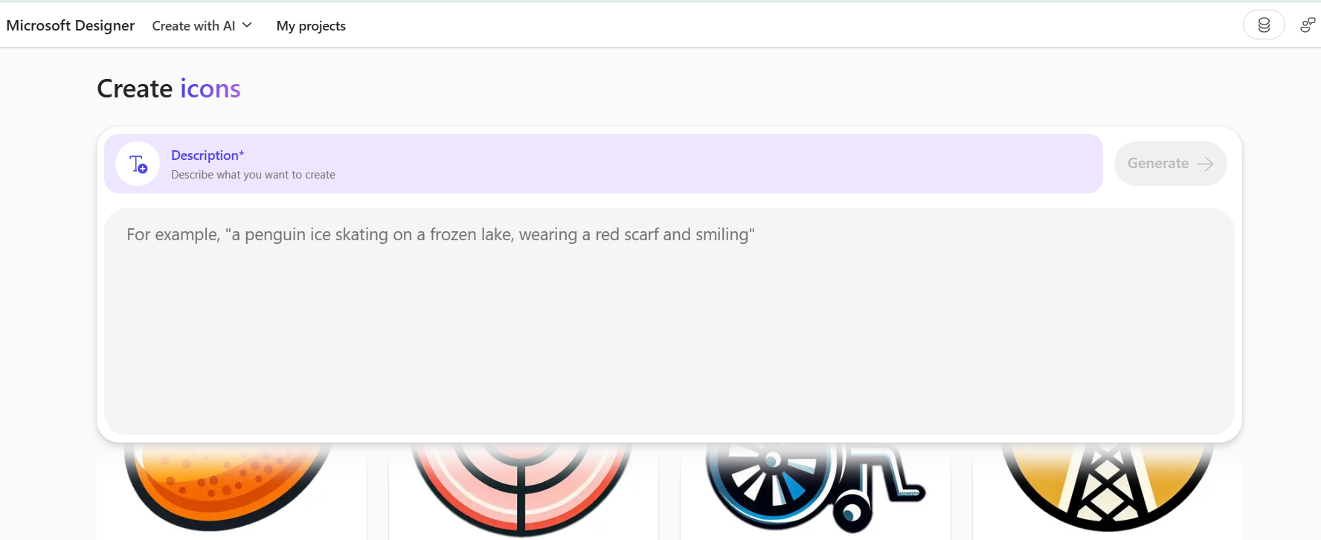

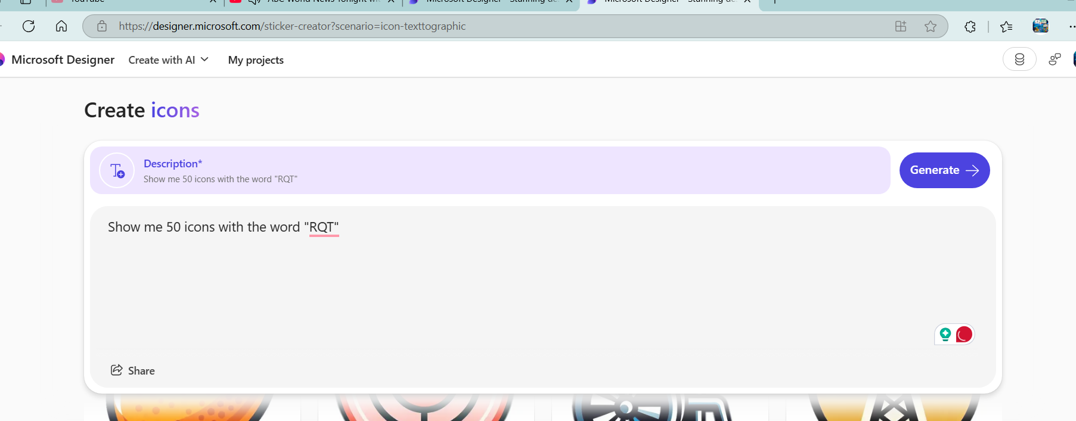

**MS Bing Chat Copilot**

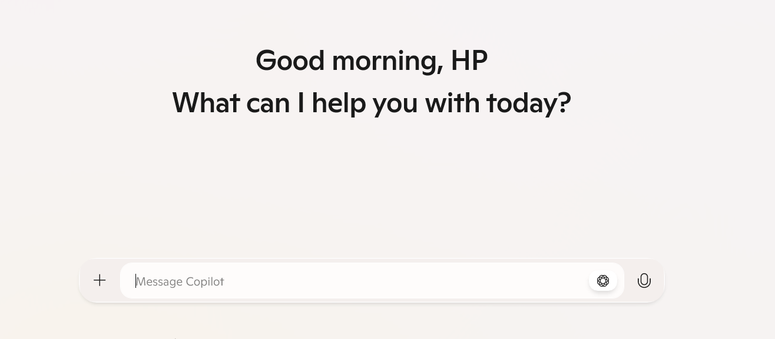

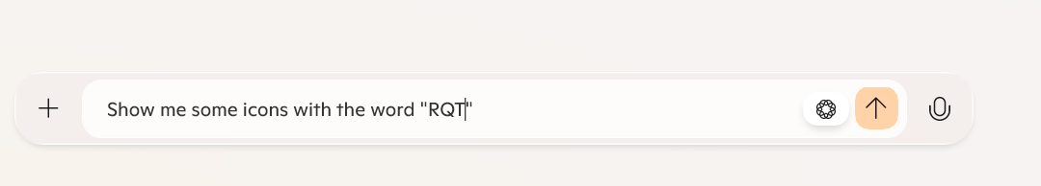

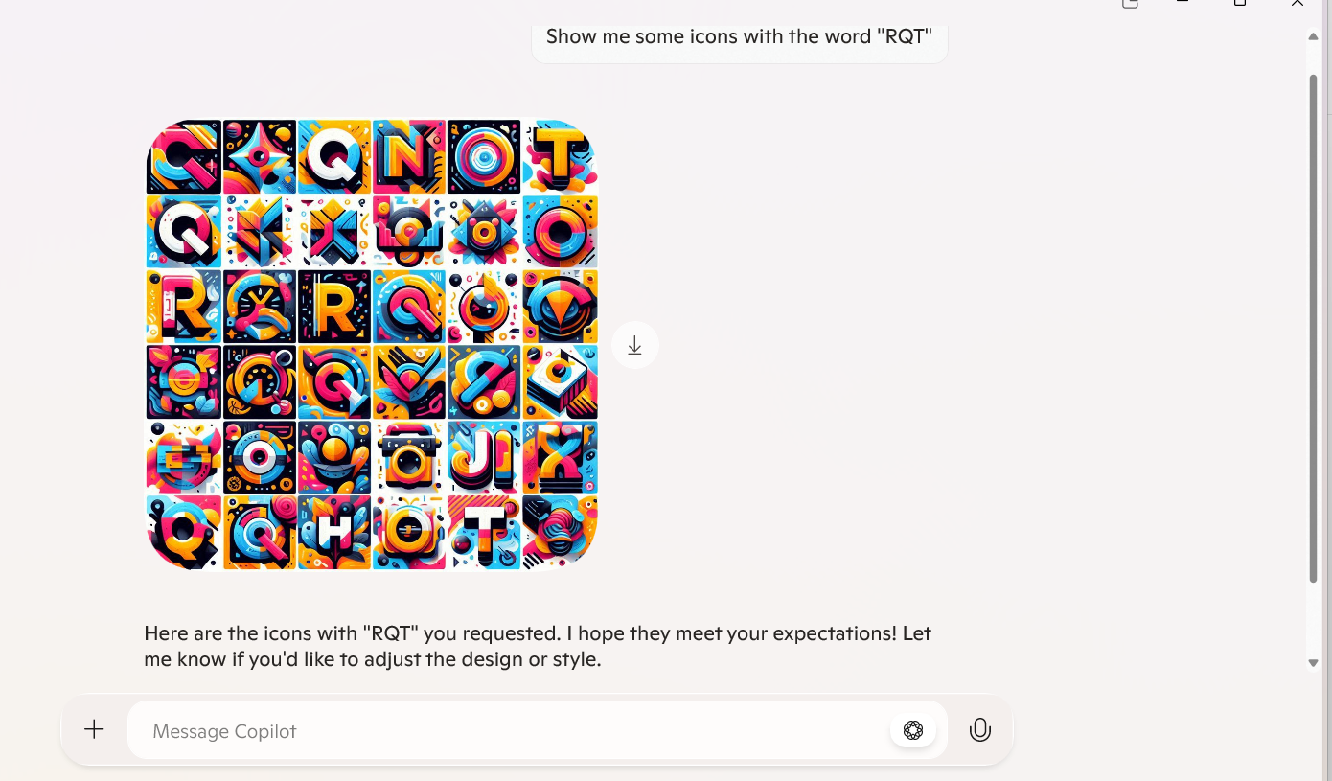

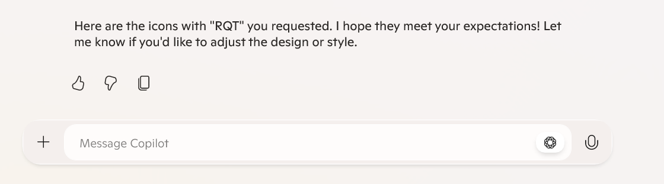

**ChatGPT**

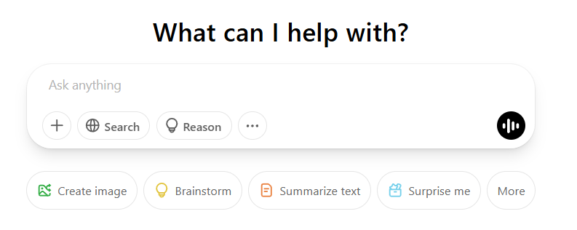

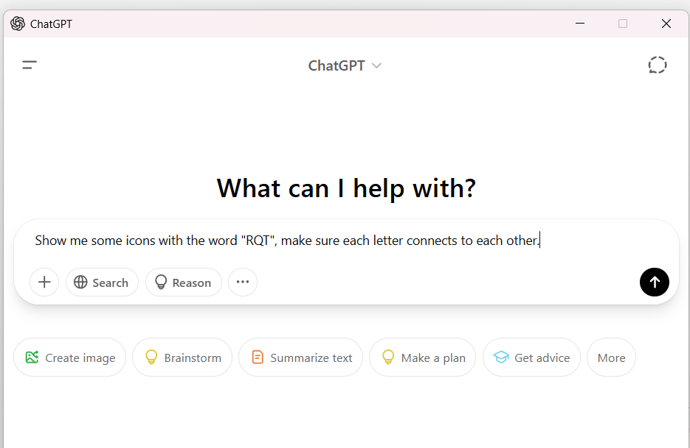

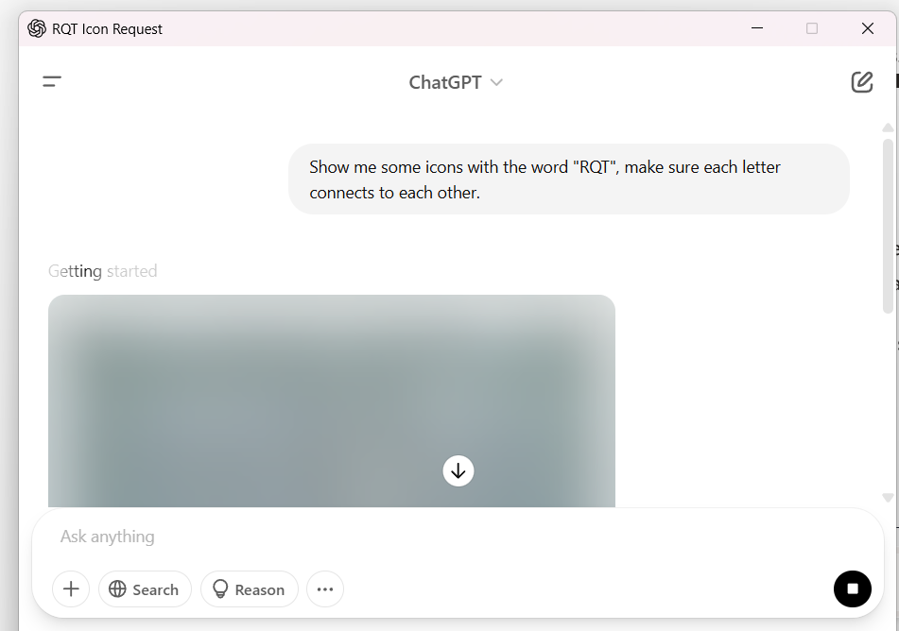

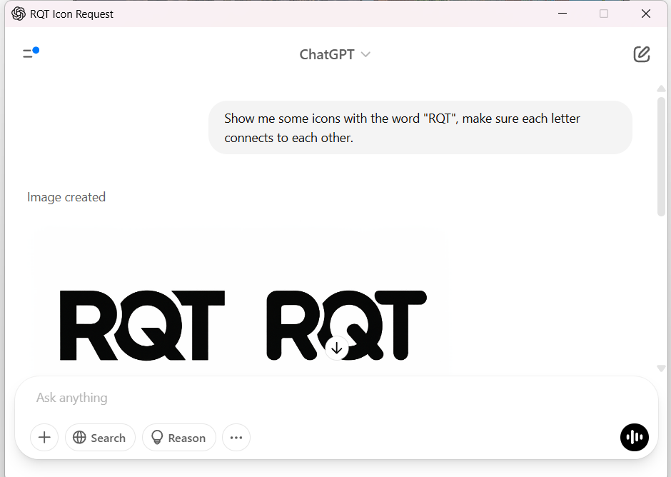

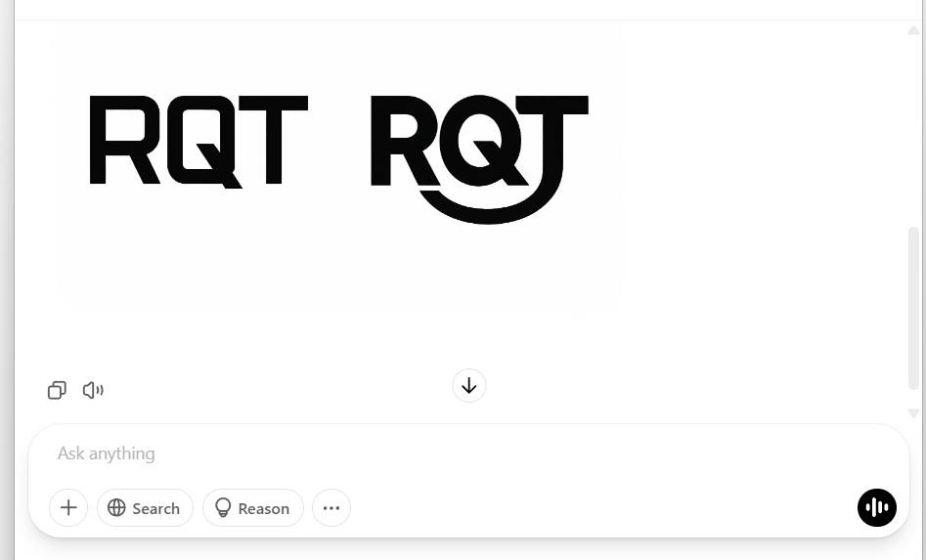

Here’s what the output of the chatbot that I came up with on 04/04/2025 1:33:AM

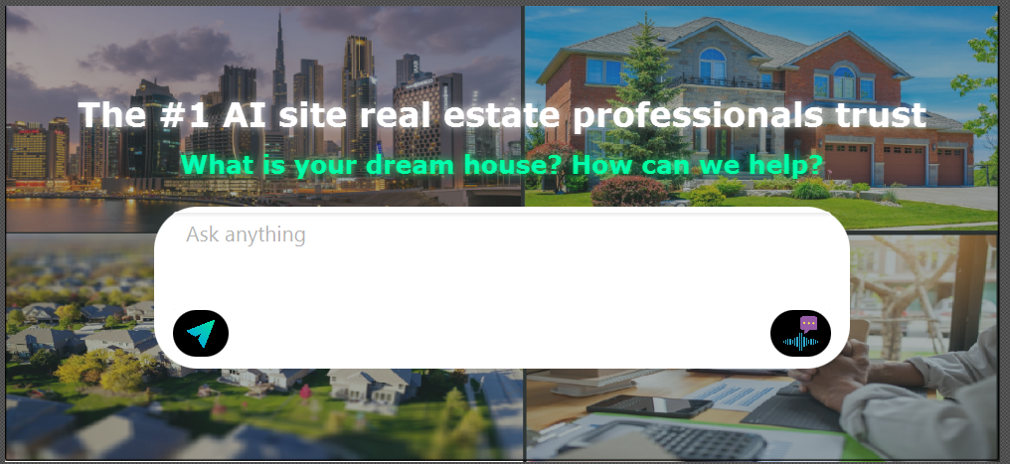

**Notice that the icon that I used for the send button and voice-message button came from website**

[**https://www.flaticon.com/**](https://www.flaticon.com/)

**\*About the text above the chat box**

+ I used 2 Label control

**1.The first Label control**

Here are some noticeable style

 The #1 AI site real estate professionals trust

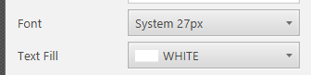

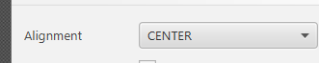

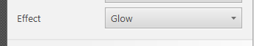

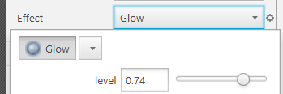

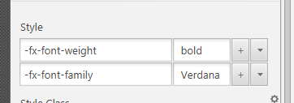

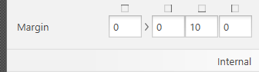

**2.The second Label control**

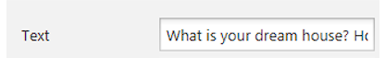

What is your dream house? How can we help?

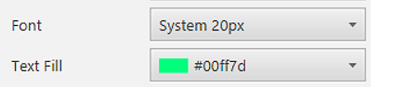

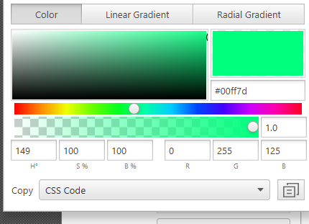

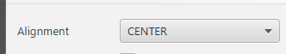

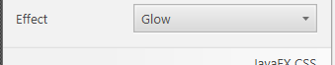

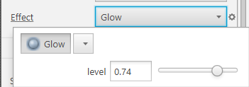

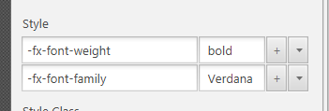

About the chatbot, first, I used VBox that contains TextArea, and BorderPane (2 buttons-1 to the left region, another to the right region)

I used JavaFX’s ImageView to create images, then wrap ImageView into ButtonBar with CSS black background color

**I made the send button, and voice message button activate or remove blue border when an user hover the mouse over it.**

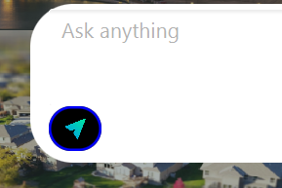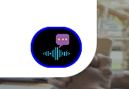

**The cursor for these buttons are “hand” so that the users know that they can click these buttons**

**I also changed the prompt text from the TextArea into “Ask anything or Describe how your dream house may look like. Our AI agent is here 24/7 to help you”**

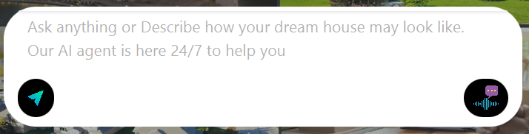

**Now the first poster container looks like this:**

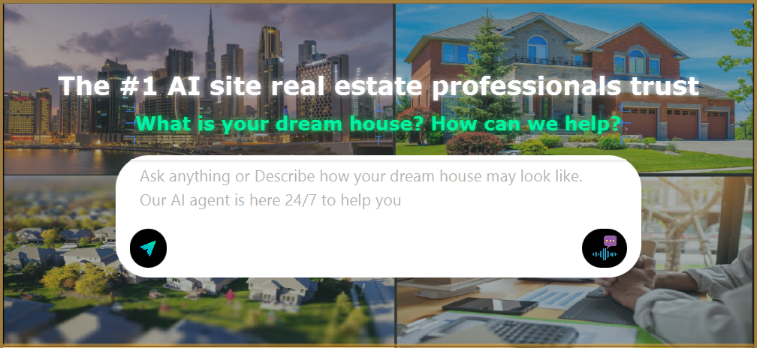

Below is the design that I finished on 04/04/2025 9pm containing Top Navigation Bar and First Poster Container

